

Course Name: Basic of Mechanical Engineering Topic: Electric Vehicles
Prepared By: Dr. Deepen Banoriya, Professor
Department of Mechanical Engineering

CONTENTS
- Introduction
- Architecture of an EV
- Essentials & Performance of EV
- Traction motor characteristics
- Tractive effort
- Transmission requirements
- Energy consumption
- Advantages & limitations
- Conclusion
- References

- Understand the architecture and essential components of electric vehicles (EVs), including their design, functionality, and key performance indicators.
- Explore the characteristics of traction motors, tractive effort, and transmission requirements, focusing on their roles in optimizing EV performance and energy consumption.
- Examine the advantages and limitations of electric vehicles, analyzing their environmental, economic, and technological impact in comparison to conventional vehicles.
Course Outcomes
CO-4: Illustrate the concepts of aerodynamics, electric vehicle
architecture, and evaluate the performance of electric vehicles.

  - Electric vehicles (EVs) represent a significant shift in transportation technology, moving away from traditional internal combustion engines (ICEs) toward electric propulsion systems.
  - EVs use electricity stored in rechargeable batteries to power electric motors, offering numerous advantages in terms of energy efficiency, environmental impact, and performance characteristics.
  - The history of EVs dates back to the early 19th century, predating gasoline-powered vehicles.
  - However, limitations in battery technology and the abundance of fossil fuels led to the dominance of ICE vehicles throughout the 20th century.

  - The 21st century has seen a resurgence in EV development and adoption due to:
    - Advancements in battery technology
    - Increasing environmental concerns
    - Government regulations and incentives
    - Improvements in charging infrastructure
    - Consumer demand for sustainable transportation solutions

  - The architecture of an electric vehicle differs significantly from that of conventional vehicles. Key components include:
    - Battery Pack
    - Electric Motor(s)
    - Power Electronics
    - Charging System
    - Transmission System
    - Thermal Management System
    - Regenerative Braking System
    - Auxiliary Systems

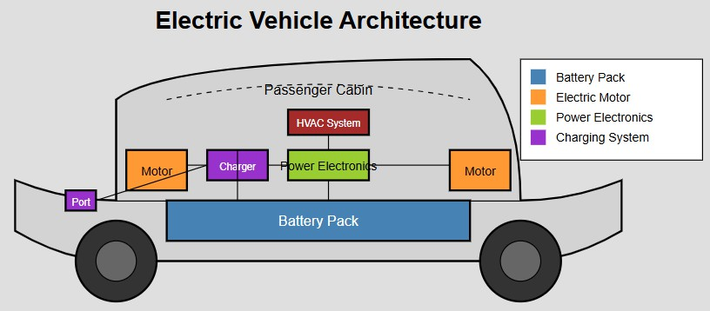

  - Battery Pack: The energy storage system, typically lithium-ion batteries arranged in modules and packs.
    - Provides power to the electric motor(s)
    - Determines the vehicle's range
    - Represents 25-40% of the vehicle's cost
  - Electric Motor(s): Converts electrical energy to mechanical energy to drive the wheels.
    - Types: Permanent Magnet Synchronous Motors (PMSM), Induction Motors, Switched Reluctance Motors Can be positioned at various locations (front, rear, or both for AWD)

Power Electronics:
    - Inverter: Converts DC power from the battery to AC power for the motor
    - Converter: Steps down high voltage to power auxiliary systems
    - Motor Controller: Regulates motor speed and torque

Charging System:
    - Onboard Charger: Converts AC power from the grid to DC power for the battery
    - Charging Port: Interface for connecting to external charging stations
    - Battery Management System (BMS): Monitors and manages battery health and performance

  - Transmission System: Typically simpler than ICE vehicles
    - Single-speed or multi-speed gearbox
    - Direct drive configurations in some designs
  - Thermal Management System: Regulates temperature of batteries and power electronics
    - Cooling systems (air, liquid)
    - Heating systems for cold weather operation
  - Regenerative Braking System: Captures kinetic energy during deceleration
    - Converts mechanical energy back to electrical energy
    - Extends range and reduces brake wear

Auxiliary Systems:
    - Power steering
    - Climate control
    - Infotainment system
    - Lighting

Essential Parameters:
- Range
- Battery Capacity
- Energy Efficiency
- Charging Rate

Essential Parameters:
- Range
- Distance travelled on a single charge
  - Dependent on battery capacity (kWh)
  - Affected by driving conditions, speed, and climate
  - Typically ranges from 160-640+ Km for
modern EVs
- Battery Capacity
- Energy Efficiency
- Charging Rate

Essential Parameters:
- Range

Battery Capacity
- Measured in kilowatt-hours (kWh)
  - Directly influences range and
performance
  - Modern EVs: 40-100+ kWh
- Energy Efficiency
- Charging Rate

Essential Parameters:
- Range
- Battery Capacity

Energy Efficiency
- Measured in Watt-hours per Km (Wh/Km) or
Km per kWh
  - Typically 3-4 times more efficient than
ICE vehicles
- Influenced
aerodynamics,
efficiency
by
vehicle weight,
and powertrain
- Charging Rate

Essential Parameters:
- Range
- Battery Capacity
- Energy Efficiency

Charging Rate
- Level 1 (120V AC): ~1.4 kW, 5-8 Km of range
per hour
- Level 2 (240V AC): 3-19 kW, 16-96 Km of
range per hour
- DC Fast Charging: 50-350+ kW, 5-32 Km of range per minute

  - Performance Characteristics:
- Acceleration
- Top Speed
- Handling
- Noise, Vibration,
and Harshness (NVH)
- Regenerative Braking
Performance

Performance Characteristics:
- Acceleration
- Instant torque delivery from electric
motors
- 0-60 Km/hr times: 2-10 seconds (depending on model)
- No gear shifting required for smooth
acceleration
- Top Speed
- Handling
- Noise, Vibration,
and Harshness (NVH)
- Regenerative Braking
Performance

Performance Characteristics:
- Acceleration

Top Speed
- Limited by motor power and gearing
- Typically 144-256 Km/hr for consumer
EVs
- Handling
- Noise, Vibration,
and Harshness (NVH)
- Regenerative Braking
Performance

Performance Characteristics:
- Acceleration
- Top Speed

Handling
- Lower centre of gravity due to battery
placement
- Even weight distribution
- Higher curb weight than comparable
ICE vehicles
- Noise, Vibration,
and Harshness (NVH)
- Regenerative Braking
Performance

Performance Characteristics:
- Acceleration
- Top Speed
- Handling

Noise, Vibration,
- Significantly quieter operation
- Reduced vibration due to fewer moving parts
- Enhanced passenger comfort
and Harshness (NVH)
- Regenerative Braking
Performance

Performance Characteristics:
- Acceleration
- Top Speed
- Handling
- Noise, Vibration,
- Kinetic
efficient
- Adjustable levels of regeneration
- One-pedal driving capability
energy
recovery:
60-70%
and Harshness (NVH)

Regenerative Braking
Performance

  - Electric traction motors for EVs have several unique characteristics that make them ideal for vehicle propulsion:
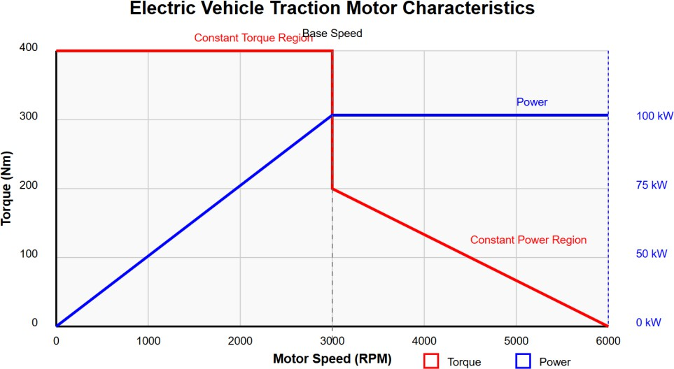
- Speed-Torque Relationship
- Torque Production
- Power Characteristics
- Efficiency
- Control Characteristics
- Thermal Characteristics

  - Electric traction motors for EVs have several unique characteristics that make them ideal for vehicle propulsion:

Speed-Torque Relationship
- Constant Torque Region: From zero to base speed, the motor delivers maximum torque
- Constant Power Region: Above base speed, torque decreases inversely with speed while power remains constant
- Base Speed: The transition point between constant torque and constant power regions
- Torque Production
- Power Characteristics
- Efficiency
- Control Characteristics
- Thermal Characteristics

  - Electric traction motors for EVs have several unique characteristics that make them ideal for vehicle propulsion:
- Speed-Torque Relationship
- High Starting Torque: 100% torque
available from standstill (zero RPM)
- Torque Density: 3-5 Nm/kg for modern EV motors
- Peak Torque: Available for
durations, typically 1.5-2
short
times
continuous torque

Torque Production
- Power Characteristics
- Efficiency
- Control Characteristics
- Thermal Characteristics

  - Electric traction motors for EVs have several unique characteristics that make them ideal for vehicle propulsion:
- Speed-Torque Relationship
- Torque Production

Power Characteristics
- Power
Density:
1-3
kW/kg
for
automotive traction motors
- Power Curve: Rises linearly in constant torque region, plateaus in constant power region
- Peak Power: Available for limited
durations to preserve thermal limits
- Efficiency
- Control Characteristics
- Thermal Characteristics

  - Electric traction motors for EVs have several unique characteristics that make them ideal for vehicle propulsion:
- Speed-Torque Relationship
- Torque Production
- Peak Efficiency: 90-97% (significantly
higher than ICE)
- Efficiency Map: Varies with speed and torque
- High-Efficiency Zone: Typically between 50-80% of rated speed and torque
- Power Characteristics

Efficiency
- Control Characteristics
- Thermal Characteristics

  - Electric traction motors for EVs have several unique characteristics that make them ideal for vehicle propulsion:
- Speed-Torque Relationship
- Torque Production
- Power Characteristics
- Fast Response: Torque response time
in milliseconds
- Four-Quadrant Operation: Forward or reverse motoring and regeneration
- Precise Torque Control: Enables
traction control and stability systems
- Efficiency

Control Characteristics
- Thermal Characteristics

  - Electric traction motors for EVs have several unique characteristics that make them ideal for vehicle propulsion:
- Speed-Torque Relationship
- Torque Production
- Temperature
Rise:
Affects
performance and durability
- Cooling Requirements: Air, liquid, or
oil cooling systems
- Derating: Performance reduction at high temperatures
- Power Characteristics
- Efficiency
- Control Characteristics
- Thermal Characteristics

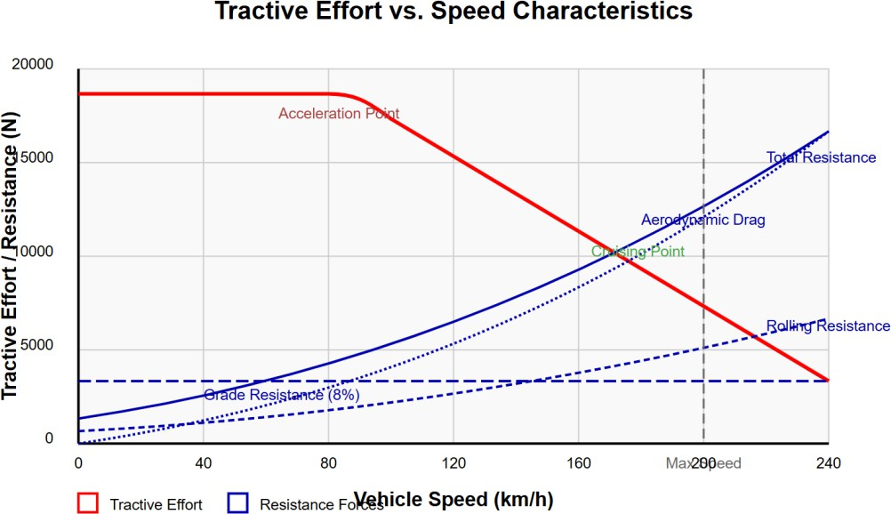
  - Tractive effort refers to the force generated by the electric vehicle propulsion system to overcome resistance forces and accelerate the vehicle. OR it is the force transmitted between the drive wheels and the road surface.
  - Some key concepts
- Definition and Calculation
- Tractive Effort Curve
- Resistance Forces
- Net Tractive Effort
- Performance Parameters
- Limiting Factors

Some key concepts

Definition and Calculation
- Tractive effort (F₁) = Torque × Gear ratio × Final drive ratio / Wheel radius
- Units: Newtons (N)
- Maximum tractive effort is limited by
motor torque and wheel-road friction
- Tractive Effort Curve
- Resistance Forces
- Net Tractive Effort
- Performance Parameters
- Limiting Factors

Some key concepts
- Definition and Calculation

Tractive Effort Curve
- Constant Tractive Effort Region: From
zero to base speed
- Decreasing Tractive Effort Region:
Above
decrease)
base
speed
(hyperbolic
- Resistance Forces
- Net Tractive Effort
- Performance Parameters
- Limiting Factors

Some key concepts
- Definition and Calculation
- Tractive Effort Curve

Resistance Forces
- Rolling Resistance: Fr = Cr × m × g
(where
Cr
is
rolling
resistance
coefficient)
- Aerodynamic Drag: Fd = 0.5 × ρ × Cd × A × v²
- Grade Resistance: Fg = m × g × sin(θ)
- Acceleration Resistance: Fa = m × a
- Net Tractive Effort
- Performance Parameters
- Limiting Factors

Some key concepts
- Definition and Calculation
- Tractive Effort Curve
- Resistance Forces
- Fnet = Ft - (Fr + Fd + Fg)
- Positive net force results in
acceleration
- Zero
speed
- Negative
net
force results in constant
net
force
results
in
deceleration

Net Tractive Effort
- Performance Parameters
- Limiting Factors

Some key concepts
- Definition and Calculation
- Tractive Effort Curve
- Resistance Forces
- Gradeability: Maximum slope the vehicle can climb at a specified speed
- Acceleration Capability: Time required to accelerate between specified speeds
- Maximum Speed: When tractive effort
equals total resistance force
- Net Tractive Effort

Performance Parameters
- Limiting Factors

Some key concepts
- Definition and Calculation
- Tractive Effort Curve
- Resistance Forces
- Net Tractive Effort
- Tire-Road Friction: Maximum tractive effort limited by μ × m × g
- Motor Power: Available torque at
different speeds
- Battery Power: Maximum current
delivery capability
- Performance Parameters

Limiting Factors

  - Unlike conventional ICE vehicles, EVs have different and often simpler transmission requirements due to the characteristics of electric motors.
  - Transmission Configurations
- Single-Speed Transmissions
- Multi-Speed Transmissions
- Direct Drive
  - Transmission Design Considerations
- Gear Ratio Selection
- Noise, Vibration, and Harshness (NVH)
- Efficiency Considerations
- Design Integration
- Control Integration

Transmission Configurations:
1)
Single-Speed Transmissions Multi-Speed Transmissions Direct Drive
reduction
10:1
to
8:1
use
- Typically
ratio
- Examples: Tesla Model S/3/X/Y, Nissan
Leaf, Chevrolet Bolt
- Most common in modern EVs
- Advantages: Simplicity, reliability,
cost-effectiveness, efficiency
2)
3)

Transmission Configurations:
- Single-Speed Transmissions

Multi-Speed Transmissions
- Two-speed or multi-speed gearboxes
- Advantages: Extended high-speed
efficiency, improved gradeability
- Used in high-performance EVs or commercial vehicles
- Examples: Porsche Taycan (2-speed),
certain Audi e-tron models
- Direct Drive

Transmission Configurations:
- Single-Speed Transmissions
- Multi-Speed Transmissions
- Direct Drive
- In-wheel
gearing
- Advantages:
motors
with no reduction
Simplified
mechanical
design, reduced drivetrain losses
- Challenges:
durability, cost
Un-sprung
weight,
- Limited
date
commercial
applications to

Transmission Design Considerations:

Gear Ratio Selection
- Low enough to provide adequate acceleration and hill climbing
- High enough to allow desired top speed
- Optimal ratio balances performance and efficiency
- Noise, Vibration, and Harshness (NVH)
- Efficiency Considerations
- Design Integration
- Control Integration

Transmission Design Considerations:
- Gear Ratio Selection

Noise, Vibration, and Harshness (NVH)
- Higher quality standards due to absence
of engine noise
- Precision manufacturing required to
minimize gear whine
- Special
techniques
damping
and
isolation
- Efficiency Considerations
- Design Integration
- Control Integration

Transmission Design Considerations:
- Gear Ratio Selection
- Noise, Vibration, and Harshness (NVH)
- Transmission efficiency typically 95-98%
- Minimal power loss due to fewer gears and simpler design
- Lubricants optimized for EV applications

Efficiency Considerations
- Design Integration
- Control Integration

Transmission Design Considerations:
- Gear Ratio Selection
- Noise, Vibration, and Harshness (NVH)
- Efficiency Considerations

Design Integration
- Compact packaging with motor and power electronics
- Cooling integration with overall thermal
management system
- Weight reduction through material
optimization
- Control Integration

Transmission Design Considerations:
- Gear Ratio Selection
- Noise, Vibration, and Harshness (NVH)
- Coordination with motor control for
regenerative braking
- Torque management for traction control
- Drive mode
Sport)
selection
(Eco, Normal,
- Efficiency Considerations
- Design Integration
- Control Integration

  - Energy consumption in EVs is a critical parameter that determines range, efficiency, and overall performance.

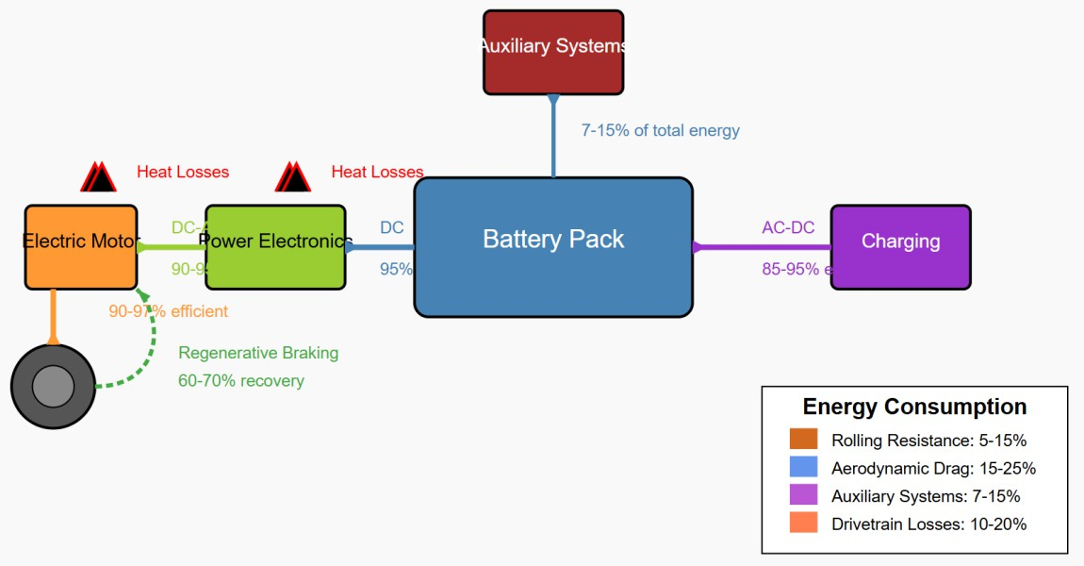
Energy Flow in EVs
- Energy Source
- Energy Conversion
Path
- Energy Consumption
Breakdown

Energy Flow in EVs

Energy Source
- Grid Electricity: AC power from charging stations or home outlets
- Onboard Storage: Battery pack (DC)
- Regenerative Braking: Recovery of kinetic
energy during deceleration
- Energy Conversion Path
- Energy Consumption
Breakdown

Energy Flow in EVs
- Energy Source

Energy Conversion Path
- Energy Consumption
Breakdown
- Charging: AC to DC conversion (85-95%
efficient)
- Battery Storage: Chemical energy storage (90-95% round-trip efficiency)
- Power Electronics: DC to AC conversion for
motor (90-95% efficient)
- Electric Motor: Electrical to mechanical energy (90-97% efficient)
- Transmission: Mechanical power transfer (95-98% efficient)

Energy Flow in EVs
    - Energy Source
    - Energy Conversion Path
- Propulsion Energy: 70-85% of total energy
consumption
- Auxiliary Systems: 7-15% (HVAC, lighting, electronics)
- Losses:
losses)
5-15%
(electrical and thermal
    - Energy Consumption
Breakdown

Factors Affecting Energy Consumption
    - Vehicle Parameters
    - Driving Conditions
    - Environmental Factors
    - Driver Behaviour

Factors Affecting Energy Consumption

Vehicle Parameters
- Mass: Linear relationship with energy
consumption
- Aerodynamics: Drag coefficient and frontal area
- Rolling Resistance:
inflation
- Drivetrain Efficiency: Motor, inverter, and transmission losses
Tire
selection
and
- Driving Conditions
- Environmental Factors
- Driver Behaviour

Factors Affecting Energy Consumption
    - Vehicle Parameters

Driving Conditions
- Speed: Aerodynamic drag increases with
square of speed
- Acceleration: Higher energy demand during acceleration
- Road Grade: Additional energy required
for uphill driving
- Traffic Patterns: Stop-and-go vs. highway cruising
    - Environmental Factors
    - Driver Behaviour

Factors Affecting Energy Consumption
    - Vehicle Parameters
    - Driving Conditions
- Ambient Temperature: Battery efficiency and HVAC demands
- Wind: Head/tailwind effects on
aerodynamic resistance
- Road Surface: Impact on rolling resistance
- Altitude: Air density effects on aerodynamic drag

Environmental Factors
    - Driver Behaviour

Factors Affecting Energy Consumption
    - Vehicle Parameters
    - Driving Conditions
- Acceleration Profile: Aggressive vs. gentle
acceleration
- Speed Management: Maintaining efficient
cruising speeds
- Regenerative
Anticipating stops
- Auxiliary System Usage: Climate control
settings
Braking
Utilization:
    - Environmental Factors
    - Driver Behaviour

Energy Consumption Metrics
    - Energy Economy
    - Range Estimation
    - Efficiency Comparison

Energy Consumption Metrics

Energy Economy
- Watt-hours per kilometer (Wh/km) or Watt-hours per mile (Wh/mi)
- Miles per kilowatt-hour (mi/kWh) or Kilometers per kilowatt-hour (km/kWh)
- Typical values: 150-250 Wh/km (240-400
Wh/mi) for passenger EVs
- Range Estimation
- Efficiency Comparison

Energy Consumption Metrics
    - Energy Economy

Range Estimation
- Range = Battery capacity (kWh) × Energy
economy (km/kWh or mi/kWh)
- Affected by all factors mentioned above
    - Efficiency Comparison

Energy Consumption Metrics
    - Energy Economy
    - Range Estimation
    - Efficiency Comparison
- Tank-to-Wheel Efficiency: 70-90% for EVs
vs. 15-25% for ICE vehicles
- Well-to-Wheel Efficiency: Depends on
electricity generation mix

Advantages of Electric Vehicles
    - Environmental Benefits
    - Performance Advantages
    - Economic Benefits
    - User Experience
    - System Benefits

Advantages of Electric Vehicles

Environmental Benefits
- Zero Tailpipe Emissions: No direct CO₂, NOₓ, or particulate emissions
- Lower Carbon Footprint: Even with current electricity mix in most regions
- Reduced Noise Pollution: Quieter
operation in urban environments
- Potential for Renewable Energy Integration: Clean energy compatibility
- Performance Advantages
- Economic Benefits
- User Experience
- System Benefits

Advantages of Electric Vehicles
    - Environmental Benefits

Performance Advantages
- Instant Torque: Superior acceleration
from standstill
- Smooth Operation: No gear shifts required for single-speed EVs
- Low Centre of Gravity: Better handling
due to battery placement
- Regenerative Braking: Energy recovery during deceleration
    - Economic Benefits
    - User Experience
    - System Benefits

Advantages of Electric Vehicles

    - Environmental Benefits
    - Performance Advantages

Economic Benefits
    - User Experience
    - System Benefits
- Lower Operating Costs: Reduced fuel and
maintenance expenses
- Fewer Moving Parts: Decreased mechanical complexity and wear
- Higher Efficiency: 3-4 times more efficient
energy conversion than ICE
- Government Incentives: Tax credits, rebates, and other benefits in many regions
- Decreasing Battery Costs: Price per kWh has fallen by over 80% in the last decade

Advantages of Electric Vehicles

    - Environmental Benefits
    - Performance Advantages
    - Economic Benefits

User Experience
    - System Benefits
- Home Charging: Convenience of "refuelling" at home
- Reduced Maintenance: Fewer service requirements (no oil changes, simpler cooling system)
- Cabin Preconditioning: Ability to
heat/cool vehicle while plugged in
- Advanced Tech Integration: Often pioneering new connectivity and automation features

Advantages of Electric Vehicles
    - Environmental Benefits
    - Performance Advantages
    - Economic Benefits
- Grid Services: Potential for vehicle-to-
grid (V2G) integration
- Energy Security: Reduced dependence on imported petroleum
- Flexibility
Compatibility
in
Energy
with various
Sources:
electricity
generation methods
    - User Experience
    - System Benefits

Advantages of Electric Vehicles
    - Environmental Benefits
    - Performance Advantages
    - Economic Benefits
- Grid Services: Potential for vehicle-to-
grid (V2G) integration
- Energy Security: Reduced dependence on imported petroleum
- Flexibility
Compatibility
in
Energy
with various
Sources:
electricity
generation methods
    - User Experience
    - System Benefits

Limitations of Electric Vehicles
    - Range and Charging
    - Cost Factors
    - Technical Limitations
    - Infrastructure Challenges
    - Manufacturing and Lifecycle Issues

Limitations of Electric Vehicles

Range and Charging
- Range
Anxiety:
Concern
about
insufficient range for longer trips
- Charging Time: Longer "refueling" time
compared
hours)
to
gasoline (minutes vs.
- Charging Infrastructure: Still developing
in many regions
- Charging Standards: Multiple competing standards and connectors
- Cost Factors
- Technical Limitations
- Infrastructure Challenges
- Manufacturing and Lifecycle Issues

Limitations of Electric Vehicles

    - Range and Charging

Cost Factors
    - Technical Limitations
    - Infrastructure Challenges
    - Manufacturing and Lifecycle Issues
- Higher Initial Purchase Price: Despite decreasing, still generally more expensive
- Battery Replacement Cost: Significant
expense if needed beyond warranty
- Electricity Rate Variability: Charging costs depend on time, location, and rate structure
- Insurance and Repair Costs: Can be higher for some EV models

Limitations of Electric Vehicles
    - Range and Charging
    - Cost Factors
- Battery Degradation: Capacity loss over time and cycles
- Cold Weather Performance: Reduced
range and charging capability
- Weight Penalties: Batteries add significant mass to vehicle
- Raw Material Dependencies: Lithium, cobalt, and other critical minerals

Technical Limitations
    - Infrastructure Challenges
    - Manufacturing and Lifecycle Issues

Limitations of Electric Vehicles

    - Range and Charging
    - Cost Factors
    - Technical Limitations

Infrastructure Challenges
    - Manufacturing and Lifecycle Issues
- Grid Capacity: Localized upgrading
needs for widespread adoption
- Charging for Multi-Unit Dwellings: Access challenges for apartment residents
- Rural Coverage: Sparse fast-charging networks outside urban centres
- Peak Demand Management: Potential grid impacts from simultaneous charging

Limitations of Electric Vehicles
    - Range and Charging
    - Cost Factors
    - Technical Limitations
- Battery Production Impacts: Energy- intensive manufacturing process
- End-of-Life Management: Battery
recycling infrastructure still developing
- Supply Chain Complexity: Global
dependencies for critical materials
- Production Scaling Challenges: Rapid industrial transformation required
    - Infrastructure Challenges

Manufacturing and Lifecycle Issues

Conclusion
Here are some important pointers summarizing the key takeaways:
- Electric vehicles (EVs) consist of key components like an electric motor, battery pack, controller, and onboard charger, integrated for efficient operation.
- EV performance depends on factors like motor efficiency, battery capacity,
energy management systems, and vehicle design.
- Traction motors in EVs are designed to provide high torque at low speeds and maintain efficiency across varying conditions.
- Tractive effort ensures sufficient driving force, while minimal or simplified
transmission designs reduce energy loss and increase efficiency.
- EVs offer lower energy consumption compared to internal combustion engines but face challenges like range limitations and battery recycling.

References
- Basics of Mechanical Engineering, Punia, Dhanpat Rai Publisher
- Basics of Mechanical Engineering, R.K. Rajput, Laxmi Publisher
- Basics of Mechanical Engineering, D.S. Kumar, Kataria Publisher
- IC Engines,V. Ganesan,Tata McGraw Hill Publisher
- Introduction to Ergonomics, R.S. Bridger, CRC Press

THANK YOU!!



